

DECCAN EDUCATION SOCIETY’S

BRIHAN MAHRASHTRA COLLEGE OF COMMERCE

AUTONOMUS, PUNE

**The Advantages of E-commerce to Economy**

Name: - Aditya Gangadhar Kalkote.

Class: - TY BBA CA

Roll no. : - 40

Subject: - E-commerce.

Topic: - The Advantages of E-commerce to Economy.

Research paper

Topic: - **The Advantages of E-commerce to Economy.**

A) Introduction:-

1) E-commerce: -

* Electronic commerce (EC) is an emerging concept that describes the buying and selling of products, services and information via computer networks, including the Internet.
* E-commerce is enabling or achieving your business objectives by using information technology to enhance or transform your business process.

2) Economy: -

* An economy encompasses all of the activities related to the production, consumption, and trade of goods and services in an entity. Whether the entity is a nation or a small town.
* It involves activities and decisions related to allocating resources to meet the needs and desires of inhabitants within that region.

B) Main concept The Advantages of E-commerce to Economy: -

* E-commerce, or electronic commerce, has greatly influenced the Indian economy, bringing about significant changes in the way business operate and consumers shop. E-commerce has played a pivotal role in simulating India’s economic growth. It has provided a platform for small and big enterprises to compete in the global market by reducing barriers to entry.
* This digital transformation is contributing to the growth of India’s economy, enhancing consumer choice and convenience, and driving innovation across sectors.
* India is yet to have a ground-breaking e-commerce success, especially in online retail. Particularly in online shopping, India has yet to see a ground-breaking e-commerce success story. More and more young people are choosing to pursue technological skills related to e-business as e-commerce in India is opening up more and more chances for work and education. One of the biggest ideas that has swept the Indian business world is e-business. It is generating a completely new economy in terms of technology, one that has enormous promise and is profoundly altering how enterprises are conducted. E-business is a representation of globalization and the pinnacle of achievement in the digital age. It has transformed and continues to revolutionize how business is done globally. Electronic commerce has evolved into one of the most effective channels for inter-organizational business activities because of the commercialization of the Internet.
* India has emerged as the fastest growing major economy in the world and is expected to be one of the top three economic powers in the world over the next 10-15 years, backed by its robust democracy and strong partnerships. Ecommerce has changed the shopping ride of Indian customers. The term 'Ecommerce' suggests that doing on-line business with the help of PC, Faxes, E-Mail and Phones. Over the last decade, the method of buying and selling the products and Page services has been altered through the online. Introduction of electronic information interchange spreads into producers, retail traders, stock market operations and travel reservations etc. that ensued throughout a larger boom of the economy. It has been begin from the term Email.In1972, IBM used the term E-commerce for the first time. E-commerce is a boom in the modern business. It is a paradigm shift influencing both marketers and the customers. Rather e-commerce is more than just another way to boost the existing business practices. It is leading a complete change in traditional way of doing business. This significant change in business model is witnessing a tremendous growth around the globe and India is not an exception.
* 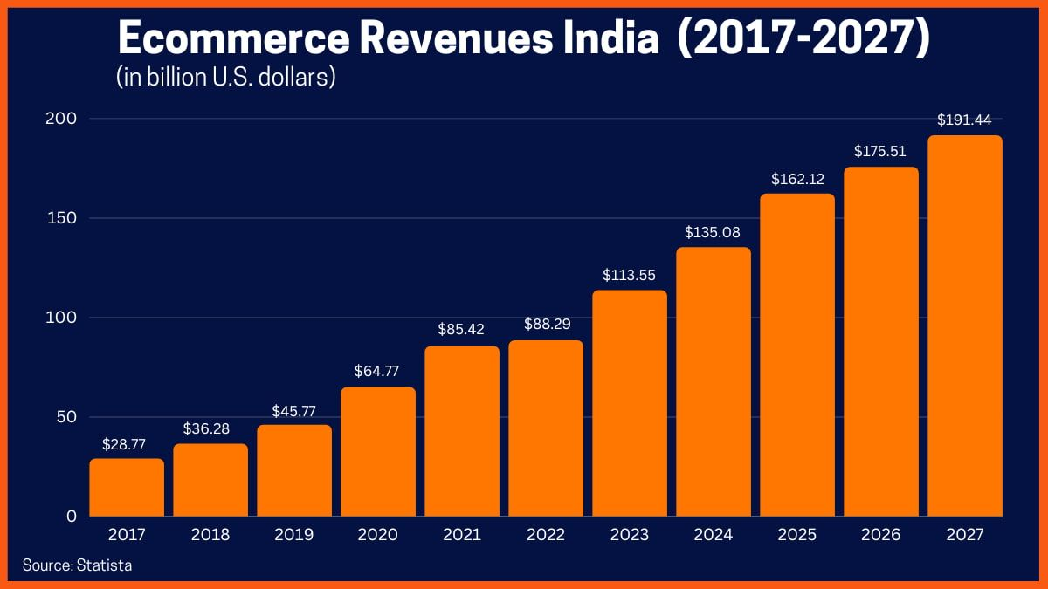 The rise of e-commerce revenues in India till 2027 is : -

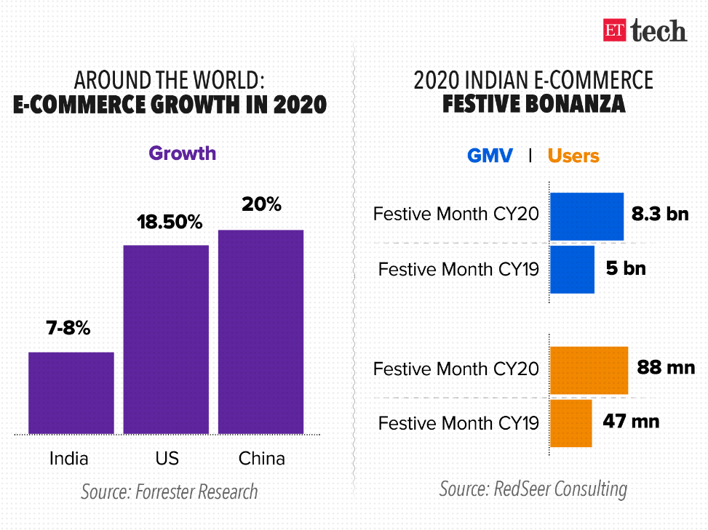There is vial rise in the sales of retail E-commerce from 2017 to 2023, per marketer retail E-commerce sales by 2023 ought to reach quite $7 million. With higher than figure square measure going to effortlessly apprehend however frequent and surprising them deification of sales pattern is world as all the most economics are shifting towards e-commerce sales.

C) The Advantages of E-commerce to Economy**: -**

E-commerce boosts the economy by increasing productivity, encouraging innovation, and driving better shopping experiences. E-commerce has empowered individuals to shop online on a global scale. In addition, e-commerce creates opportunities for protecting for the planet, both for forward thinking sellers and for eco-conscious shoppers.

1) **Sustained Growth Leads to Greater Innovation:**

Ecommerce is growing at a striking pace. The current ecommerce is driving entrepreneurship and encouraging businesses of all sizes to compete. This sustained growth and activity leads to more online experiences for all customers. The increase in online shopping generates new economy growth and innovation among sellers, getting them to pinpoint what makes their product unique and create a compelling experience that helps in customer retention. Ecommerce has grown in popularity because of the convenience, value, and choice it offers consumers.

2) **The Impact of Ecommerce on B2B Sellers and B2C Sellers:**

The growth of B2B ecommerce and its technology has also contributed to higher order volume, more efficient supply chains, and less expense involved in order management for wholesalers, manufacturers, and distributors alike. Ecommerce has also had a major impact on B2C sales. In particular, many digital-native brands, start-ups, and legacy companies have found great success with the direct-to-consumer model. The growth of e-commerce also increased career opportunities in the ecommerce realm, including sales, marketing, design, web development, and IT roles.

3) **Ecommerce Creates a More Savvy Consumer:**

Ecommerce has made it easy for buyers to shop anytime, anywhere and on any device without being limited by store hours or geographic location. Consumers can access to a nearly endless amount of products and goods, and they can easily compare prices, features, brands, and companies. This ease of access has led to consumers being more tech-savvy, connected, and engaged. An increased focus on customer experience also led to demands and regulations around greater accessibility online, as well as an online community of shoppers who to keep coming back to their website online store.

4) **Ecommerce Offers Benefits for the Environment:**

Beyond the ways, ecommerce can improve the economy of a country; it can also reduce its carbon footprint. According to a global study by Generation IM, ecommerce is 17% more carbon-efficient than traditional retail stores. Carbon efficiency includes areas of the business like product transport, buildings, warehouses, product packaging, and manufacturing. Since online companies rely less on physical store locations, they have more flexibility when it comes to implementing measures that can reduce their carbon emissions. With growing concerns about its impact on the environment, Today’s shoppers are calling for businesses to be more sustainable and transparent; today’s shoppers prefer to buy from eco-friendly brands.

5) **Ecommerce is good for the Planet and the Economy:**

The rapid shift from offline to online sales has shown no signs of slowing down. E-commerce boosts the economy by increasing productivity, encouraging innovation, and driving better shopping experiences. In addition, ecommerce creates opportunities for protecting the planet, both for forward-thinking sellers and for eco-conscious shoppers. As ecommerce continues to grow, the economic and environmental benefits are sure to follow.

D) **Digital Penetration in the Indian Economy:**

With the rise of e-commerce in India, and its significant contribution and rising e-commerce share in total retail sales, the country has seen an increase in the penetration rate of smartphones over the years. As a result, it is crucial to have an active smartphone with a reliable internet connection. 18.21% of all Indians had smartphones in 2015 and by 2023, that percentage in India reached close to 71% (Source: google.com).

A penetration rate that the U.S. already reached in 2019.

With the rise in smartphone usage and improved internet access, e-commerce will increasingly have an impact on the Indian economy. The graph above shows growth in India's adoption of digital technology, which is projected to reach 71 percent by 2023 from 30 percent in 2014. The availability of many electrical appliances and their favourable effects have contributed to this rising trend. We should thus be aware of where the populace has gone and what they have been doing because of the increase in digital penetration, claims stastia.com. Therefore, according to stastia.com data, different classed individuals in India's digital community in January 2017 came under distinct subsections, which ultimately had an impact on e-commerce in India.

E) ADVANTAGES OF E-COMMERCE:

1. No geographical barriers
2. Safe and secure
3. Stand out from the competition
4. E-Commerce is more affordable
5. Marketing is easier
6. Find customers before they find you
7. Trackable metrics and goals
8. Better customer experience

F) DISADVANTAGES OF E-COMMERCE:

1. Lack of personal touch
2. Lack of trust in quality
3. Online payments

G) GOVERNMENT INITIATIVES AND DIGITAL PENETRATION IN INDIAN ECONOMY

1. Since 2014, the Government of India has introduced various initiatives namely, Digital India, Make in India, Start-up India, Skill India and Innovation Fund, e-governance. The timely and advantageous implementation of such applications will likely help the e-commerce growth in the country.

2. In order to enlarge the participation of overseas business in the e-commerce field, the Indian Government hiked the foreign direct investment (FDI) in the Ecommerce market up to one hundred percent (in B2B models).

3. The heavy funding of Government of India in rolling out the fiber community for 5G, will assist raise ecommerce in India.

4. Government has allotted Rs.8,000 crores to Bharat-Net Project, to provide broadband services to 150,000 gram panchayats.

5. Under the Digital India movement, government launched a range of initiatives like Udaan, Umang, Start-up India Portal etc.

6. Under the mission Internet-Saathi, the authorities has influenced over sixteen million female in India and reached 166,000 villages.

7. Udaan, a B2B online change platform that connect small and medium measurement manufacturers and wholesalers with on-line outlets and also provide them logistics, repayments and technology support, have dealers in over eighty cities of India and provides to over 500 cities.

8. The government delivered Bharat Interface for Money (BHIM), a simple mobile primarily based platform for digital payments.

How ecommerce will change in 2024?

* The focus on sustainability and eco-friendliness has gained momentum in recent years. In 2024, this trend will likely intensify in the e-commerce industry. Customers expect e-commerce platforms to offer eco-friendly options, reduce packaging waste and embrace sustainable practices.

What is the economic impact of online shopping in India?

* Online shopping has positive effects on Indian economics. It not only facilitates more trades but also helping many sectors in its course like courier firms. Its contribution to GDP will increase exponentially. In a nutshell, if you have a good business and you are not online, you are missing a large potential market.

Conclusion:

The advent of e-commerce has undoubtedly reshaped the landscape of the Indian economy, offering boundless opportunities for growth, innovation, and connectivity. As highlighted throughout this paper, the impact of e-commerce transcends mere transactions; it fosters entrepreneurship, empowers consumers, and catalyses environmental sustainability.

E-commerce has emerged as a driving force behind India's economic expansion, fostering a digital revolution that permeates every facet of society. From small-scale enterprises to global conglomerates, businesses of all sizes have leveraged the power of online platforms to reach wider audiences and enhance operational efficiency. This digital transformation has not only fuelled economic growth but has also paved the way for India to emerge as a global leader in the digital economy.

Moreover, the proliferation of smartphones and improved internet access has democratized access to e-commerce, enabling individuals from diverse backgrounds to participate in the digital marketplace. As digital penetration continues to deepen, the economic implications of e-commerce are poised to become even more pronounced, with online platforms serving as engines of inclusive growth and socioeconomic development.

Looking ahead to 2024 and beyond, the e-commerce landscape is poised for further evolution, with a heightened emphasis on sustainability and eco-friendliness. Consumers are increasingly demanding environmentally conscious practices from e-commerce platforms, driving a shift towards more sustainable business models and supply chain practices.

In conclusion, the economic impact of online shopping in India is profound and multifaceted. It has not only revolutionized the way commerce is conducted but has also unleashed a wave of innovation, entrepreneurship, and social empowerment. As India continues its journey towards digital transformation, e-commerce will remain a cornerstone of economic development, driving prosperity, and progress for generations to come.